Capstone AI Questions
Annika Arel

Question 1: I would like some guidance on starting my Tkinter Canvas Module GUI. This is one of my first steps in creating my project and I'm unsure where to start with GUI.
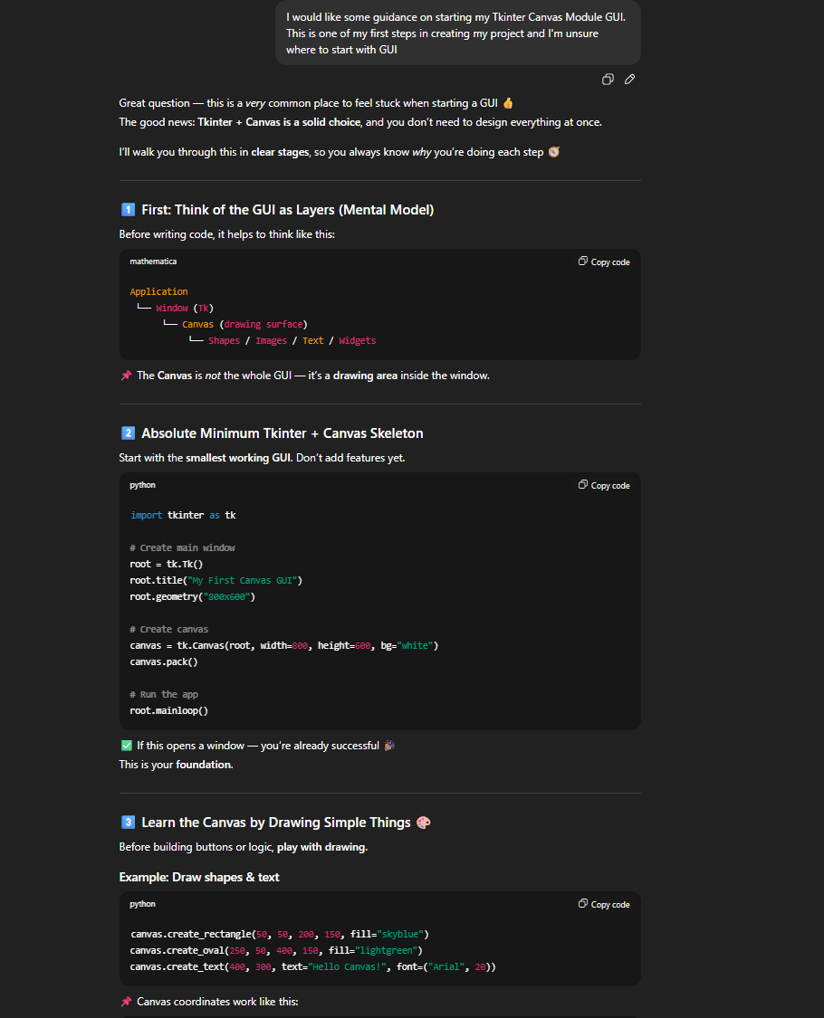
My Followup:
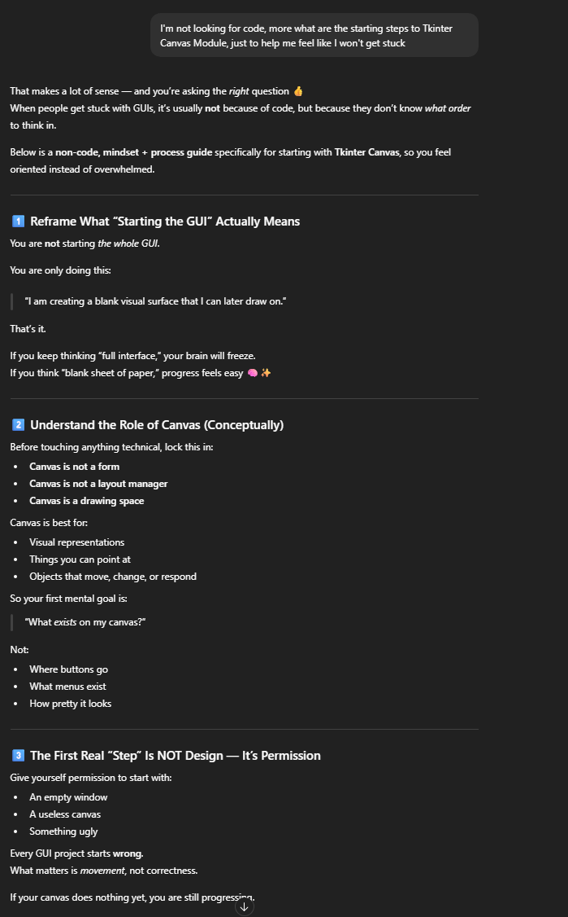
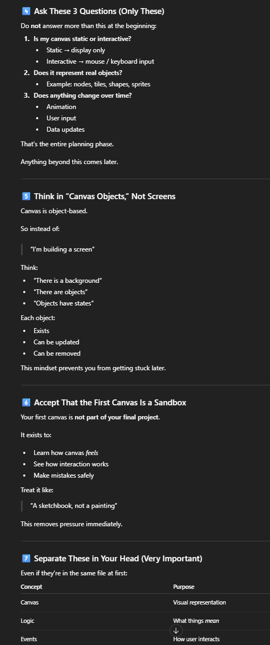
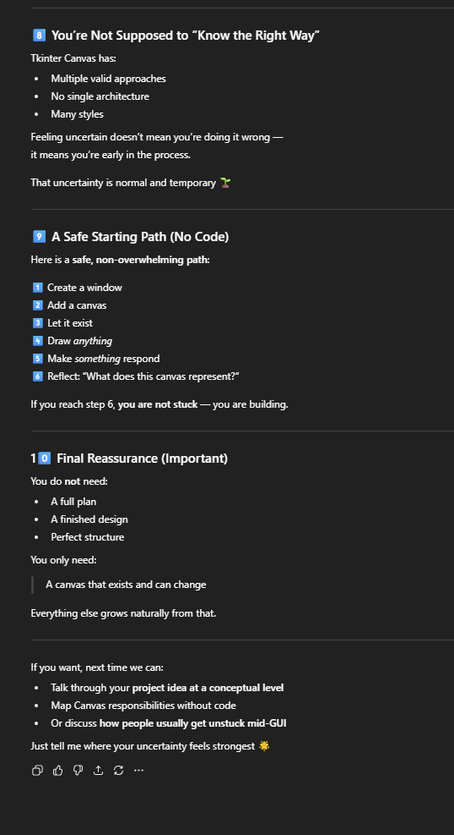
Looking at these responses, I think it helped with learning how to start, not thinking about the entire project and what I want the whole thing to look like, more with I need to understand that it starts out empty like a blank paper, and I can add to it when I feel fit. This really helped with feeling overwhelmed about something I’ve never done before like Tkinter, and I now can see how to start.

Question 2:
I am building an attack and defense simulation with Python 3.11, JSON, Tkinter canvas module, and PyInstaller. One of the parts of my project is how to display those attacks, I just want the display to mock results of scans and show the defense actions that you can take.
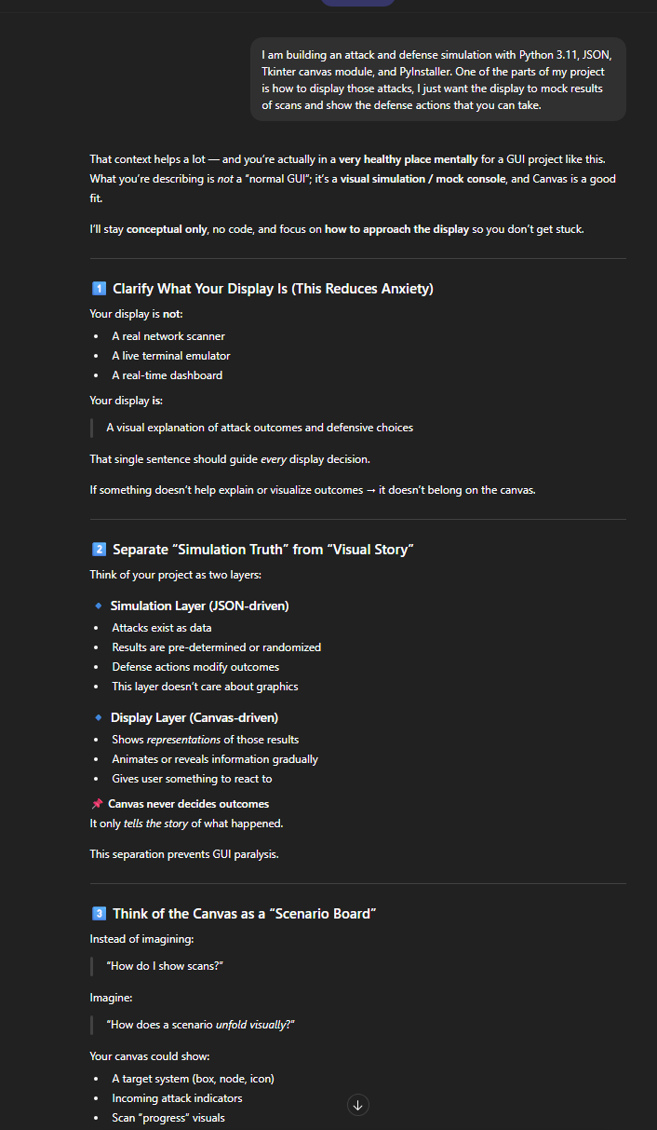
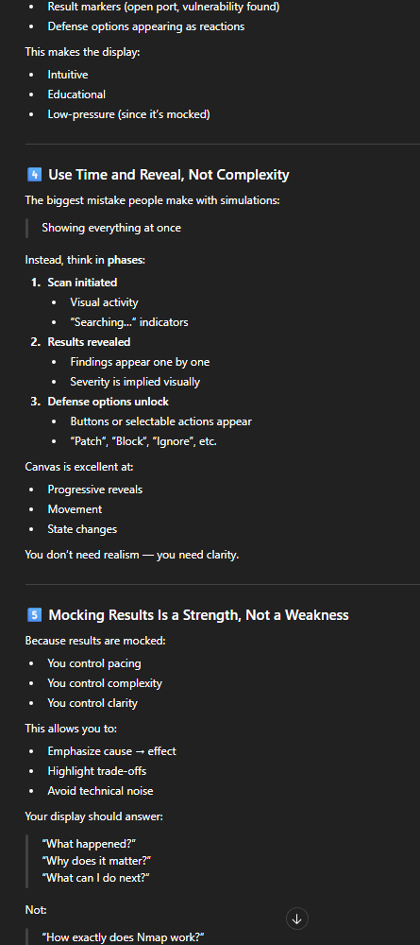
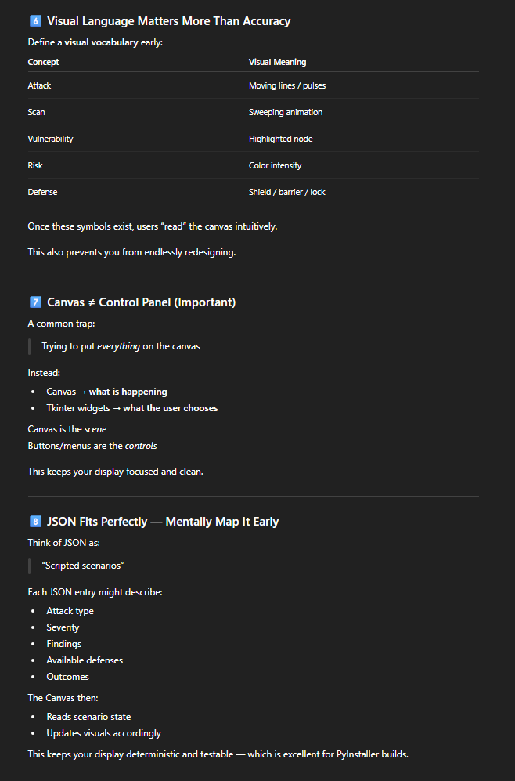
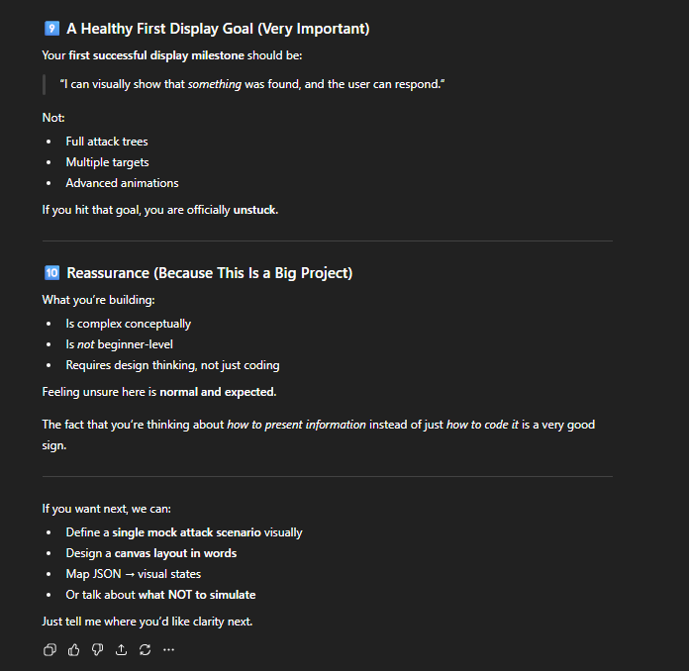
In order for my project to showcase and simulate attacks, people need to know what that looks like in order for them to understand. This is a huge part of my project, so making sure that I clarify what my display is can be really helpful. ChatGPT showed me that this part of my project can have a lot of questions like how do I want this visually to unfold and that this can make this more educational if I ask those questions and make sure I’m not just showing the scans, but more how this scenario could really unfold. It also explained how I can have control, like cause/effect, why does it matter, and what to do next.

Question 3: Using PyInstaller for standalone executable files, is what I will be doing so this can be an application rather than a script. How can I make sure that everything can be put into PyInstaller as an application and not a script?
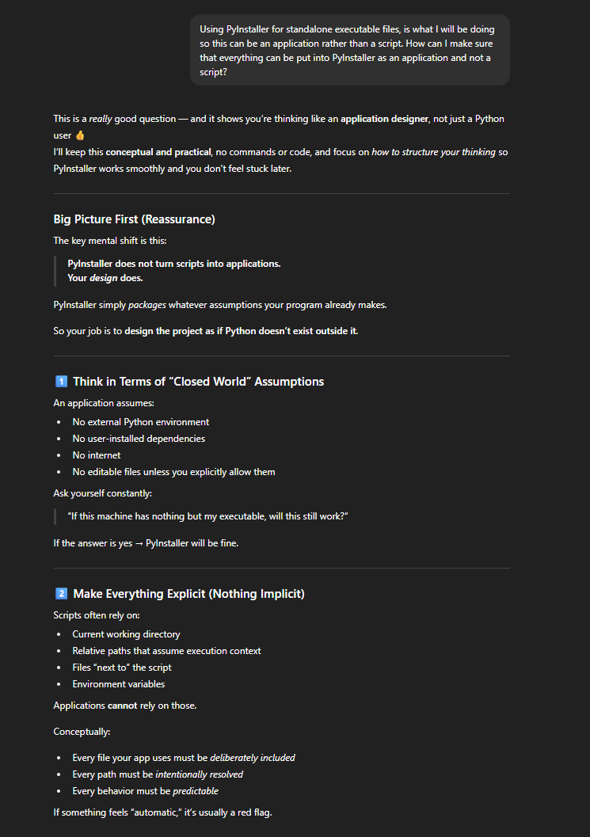
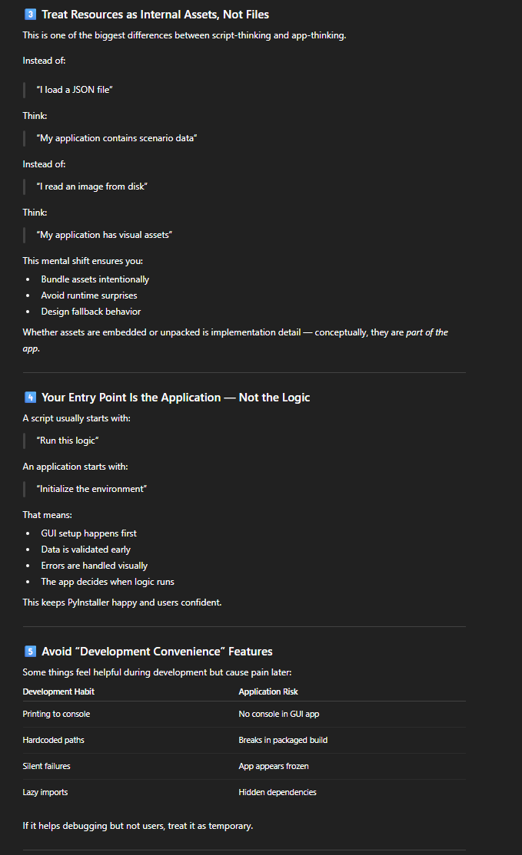
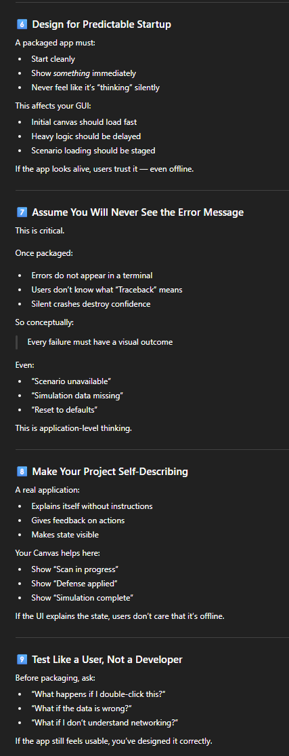
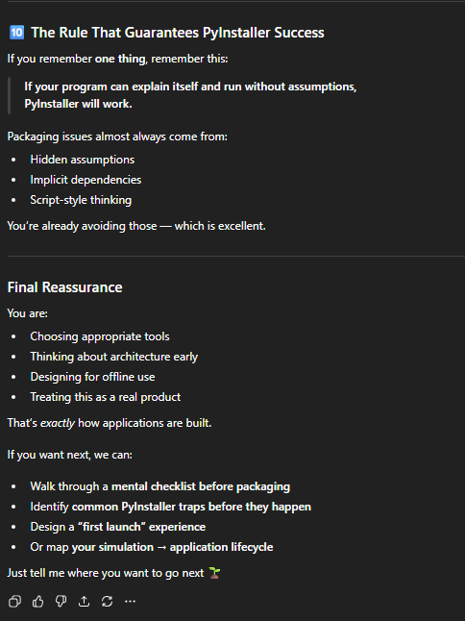
Using PyInstaller is very new to me, figuring out how it works before I start my application is very important. This is important because I didn’t know that you have to write some of the code differently in order for it to work as an application rather than a script. This taught me I have to write things like internal assets and not files, instead of running this logic, I will be initializing the environment. This makes me think more like the application designer rather than just coding python and hoping it works.

